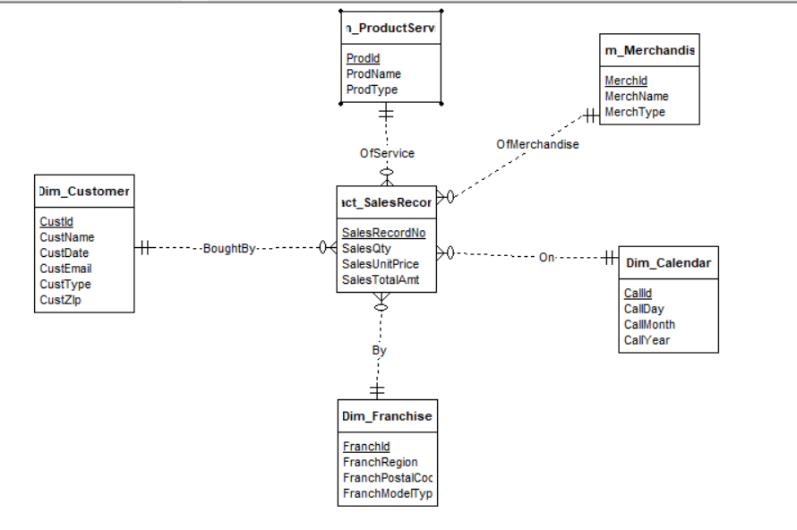

The diagram shows the star schema, with Fact_salesrecord as the middle and other dimensions have 1 to Many relationships to it.